Pokhara University

Level: Bachelor | Semester – Fall | Year : 2008
Programme: BE |  | Full Marks : 100
Course: Electronic Circuits I |  | Time : 3hrs.

Candidates are required to give their answers in their own words as far as practicable.
The figures in the margin indicate full marks.

Attempt all the questions.

1. | - Draw Emitter follower circuit and derive the expression of input impedance and voltage gain. Draw the conclusions from the expressions.  - Calculate Overall Voltage gain for the given BJT amplifier.  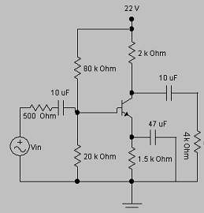 | 8  7
2. | - Define Lower cut off frequency, Upper cut off frequency and Bandwidth. Explain why Cut off Frequency is also called 3 dB frequencies? Draw necessary Waveforms.  - Briefly explain various types of distortions. | 8  7
3. | - Draw Direct Coupled Load Class A amplifier and show that its maximum possible efficiency is only 25 %  - Draw complementary symmetry class B push pull amplifier and explain its operation. What is cross over distortion? | 7  8
4. | - What are the main advantages of Negative Feedback? Briefly explain how bandwidth improves after negative feedback.  - An amplifier has an open loop gain of 600 and a feedback ratio of 0.08. If the open loop gain changes by 15 %, find the percentage change in closed loop gain. | 8  7
5. | - Draw Wein Bridge oscillator and explain its operation. Derive the expression of its resonance frequency.  - Draw LC tuned Hartley oscillator and explain its operation. | 8  7
6. | - Draw Full Wave Bridge rectifier circuit and explain its operation. Derive the expression of its average voltage, rms voltage and Ripple factor.  - Briefly explain how PI Filter works? | 8  7
7. | Write short notes on (Any Two)  - Effects of bypass Capacitor on frequency response  - Voltage Series Negative feedback connection( Derivation of Input/output impedance  - Choice of transistor in intermediate stages while cascading  - Crystal oscillator | 5×2

